SACRAMENTO COUNTY OPIOID COALITION
SUBSTANCE USE PREVENTION AND TREATMENT REPORT
2/26/24

- Data-Sacramento County
- 2023: 331 fentanyl involved deaths (not final count still open cases)
- Jan 2023: 31 deaths, Jan 2024, 9 deaths
- CDC – 7/10 pills on street and online laced with Fentanyl

- Sacramento County Prevention Summit – March 14, 8-3:30 pm, DoubleTree Hilton Hotel

Registation Open : www.sacramentosccy.org

- Fentanyl Awareness and Action Summit, COMING SOON AUG 2024!

- New County Contracted MAT Provider – Transitions Clinic in Oak Park

- Safer Sacramento – www.safersacramento.com Updates:

- New Videos – Grieving parents and friends of loved ones lost
- Harm Reduction Blog
- Youth, Reaching Diverse Communities, Grief and Senior/Older Adult Pages Coming
- Follow Safer Sacramento on Facebook and TikTok

Postcard of Those Lost in Sacramento for download: Remembrance Page – Safer Sacramento

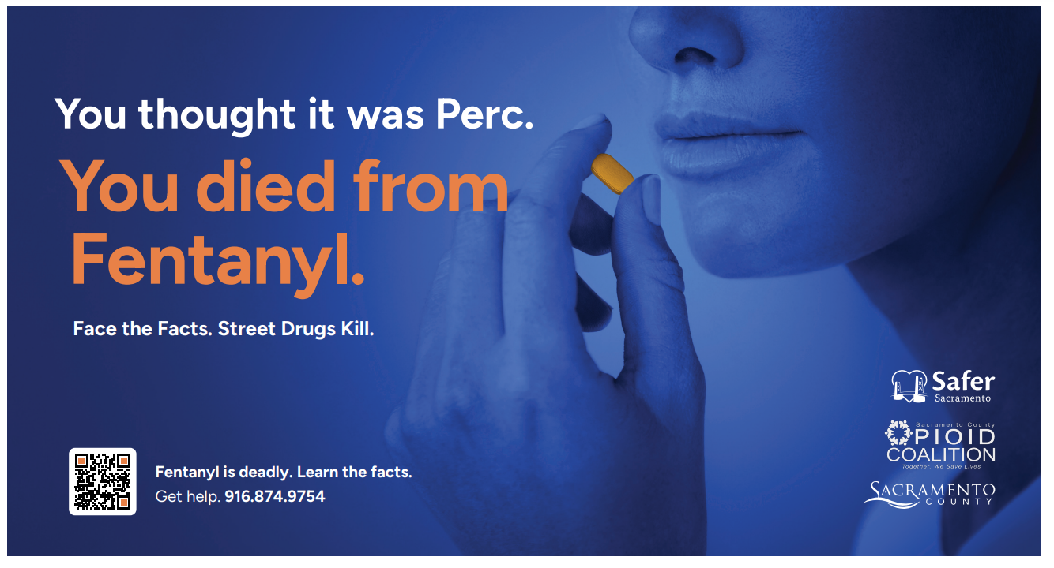

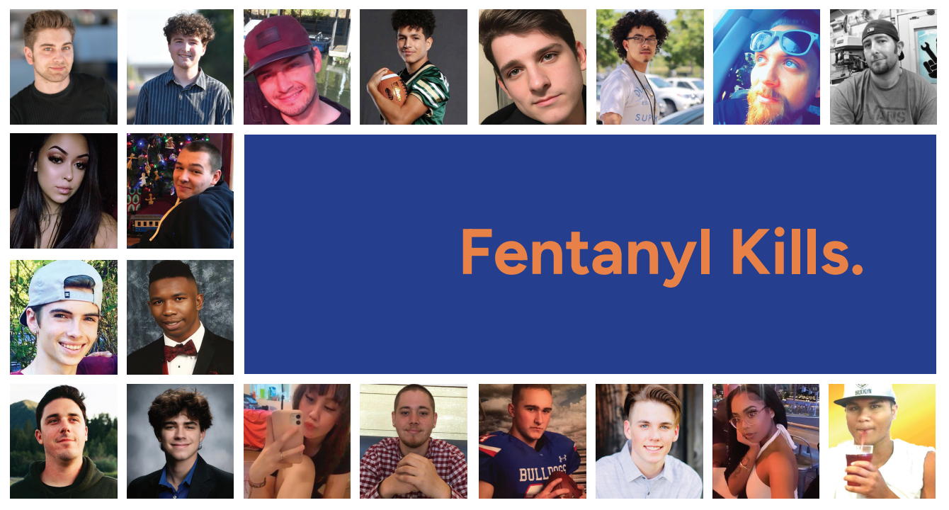

- Future Focused: Fentanyl Awareness and Education in Schools
County contracted prevention provider
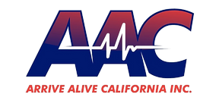
- 2023: Impacted 37, 740 people through 63 events including middle and high school assemblies, classroom education, parent meetings and town halls

- Senate Bill (SB) 10 – Passed 10/23 - Fentanyl Protocols Required for Schools
outreach, awareness, Narcan, OD prevention, school safety plan

- New state law requires fentanyl test strips on CA community and state college campuses

- Narcan Distribution and Ordering Process
Contact Janelle Gonzales; Gonzalesjan@saccounty.gov for information and Narcan

- Sacramento County :
www.safersacramento.com
DHS-SUPT@saccounty.gov

- DHCS Naloxone Distribution Project : https://californiaopioidresponse.org/matproject/naloxone-distribution-project/

- Opioid Settlement Funding – New and Expanded Sacramento County Contracted Services to Address the Opioid Crisis

- Harm Reduction Services/SANE - MAT, Narcan distribution
- NTI Upstream/Safer Sacramento Prevention Project and Website
- Voice of the Youth – opioid education, prevention to African American youth ages 12-24
- Omni Youth Services, prevention education to hard to serve culturally diverse communities
- Center for Collaborative Planning/expand See Her Bloom campaign, opioid education and resources to African American women
- Sac Metro Fire Mobile Integrated Health/MAT services and Narcan distribution

- NEW DA Fentanyl Rapid Response Team
- Sacramento County District Attorney Thien Ho, in his first-ever "State of Public Safety" address, laid out his plans for the future in addressing crimes.

- Members of the Fentanyl Rapid Response Team will be all law enforcement officers who have experience in investigating these sorts of cases and prosecutors who can quickly assess the situation and help out.

- Parent Resource - “New Drug Talk”, www.SongforCharlie.org

This site provides education, free tools, and expert advice to help CA families connect and stay safe.

- DEA Prescription for Disaster – How Teens Misuse Medicine, DEA 1PILLCANKILL on college campuses

- CA Bridge Program – Collaborate with local ED’s for OUD’s, Bup/MAT

- MAT for Youth and Adults

