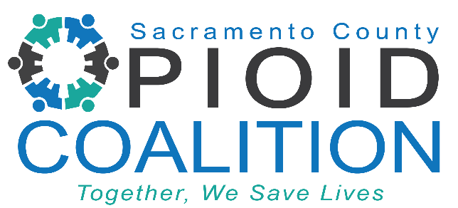
Sacramento County Opioid Coalition Meeting
Time: October 16, 2023 02:00 PM PT
Link Here
Meeting ID: 824 8938 1147
Passcode: 435773
One tap mobile
+16694449171, 8694068688# US
+16699006833, 8694068688# US (San Jose)

Who we are: The Sacramento County Opioid Coalition is a collaboration of healthcare professionals, community-based organizations, law enforcement, County agencies, and concerned citizens determined to turn the tide of our local opioid epidemic.

Mission: We are committed to saving lives by preventing overdoses through expanding treatment access, promoting safe disposal, encouraging early intervention, treatment and recovery, enhancing opioid surveillance, and expanding public education and media outreach.

AGENDA

- Welcome by Facilitators 5 min
  - Lindsay Coate, Co-Chair, Sacramento County Opioid Coalition
- SCOC Community Updates 15 min
  - Gone too Soon Campaign, Narcan Updates
  - Lori Miller, LCSW, Division Manager, Sacramento County Department of Health Services, Substance Use Prevention and Treatment– Community and SUPT Updates
  - Amber Arif, Program Coordinator, Sacramento County Opioid Coalition – 2023 Summary of Coalition Activities
- 2023 Fentanyl Prosecution Summary 15 min
  - US Attorney Phillip Talbert
- Fentanyl and Bioterrorism 20 min
  - Jean Ventura, Supervising Microbiologist/Bioterrorism Coordinator, CDPH
  - Nicholas Callahan, Weapons of Mass Destruction Coordinator (WMD)/FBI Agent
- Fentanyl Exposure – Mythbusters 5 min
  - Amber Arif, Program Coordinator, Sacramento County Opioid Coalition
- Opioid Use Disorder, MAT, and Black Voices 15 min
  - BJ Davis, Executive Director, Sacramento Recovery House
- Lived Experience Short Videos 15 min

