SACRAMENTO COUNTY OPIOID COALITION
SUBSTANCE USE PREVENTION AND TREATMENT REPORT
6/10/24

- Data-Sacramento County Coroner
- 2023: 410 fentanyl involved deaths (not final count still open cases)
- 2024: 86
- 2022: 226; 2021: 215
- CDC – 7/10 pills on street and online laced with Fentanyl
- Fentanyl Dashboard on Coroner website

- Safer Sacramento – www.safersacramento.com Updates:

- NEW Blog – “The Ripple Effect”. 3rd blog live of Documentary style 8 part series.
- Youth, Reaching Diverse Communities, Grief and Senior/Older Adult Pages Coming
- Follow Safer Sacramento on Facebook, Instagram and TikTok

- Narcan Distribution and Ordering Process
Contact Janelle Gonzales; Gonzalesjan@saccounty.gov for information and Narcan

- Sacramento County :
www.safersacramento.com
DHS-SUPT@saccounty.gov

- DHCS Naloxone Distribution Project : https://californiaopioidresponse.org/matproject/naloxone-distribution-project/

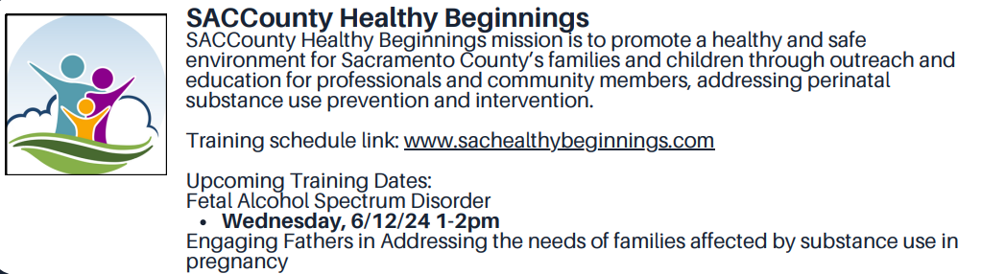
- NEW DA Fentanyl Rapid Response Team
- Sacramento County District Attorney Thien Ho, in his first-ever "State of Public Safety" address, laid out his plans for the future in addressing crimes.

- Members of the Fentanyl Rapid Response Team will be all law enforcement officers who have experience in investigating these sorts of cases and prosecutors who can quickly assess the situation and help out.

- 2024 Fentanyl Action and Awareness Summit

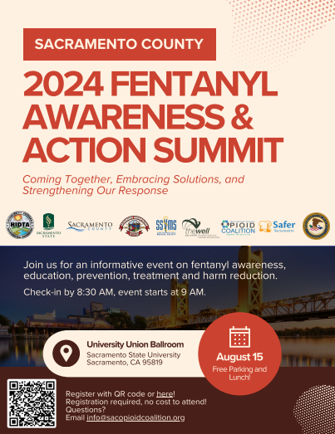

- Opioid Settlement Funding – New and Expanded Sacramento County Contracted Services to Address the Opioid Crisis

- Harm Reduction Services/SANE - MAT, Narcan distribution
- NTI Upstream/Safer Sacramento Prevention Project and Website
- Voice of the Youth – opioid education, prevention to African American youth ages 12-24
- Omni Youth Services, prevention education to hard to serve culturally diverse communities
- Center for Collaborative Planning/expand See Her Bloom campaign, opioid education and resources to African American women
- Sac Metro Fire Mobile Integrated Health/MAT services and Narcan distribution
Postcard of Those Lost in Sacramento for download: Remembrance Page – Safer Sacramento

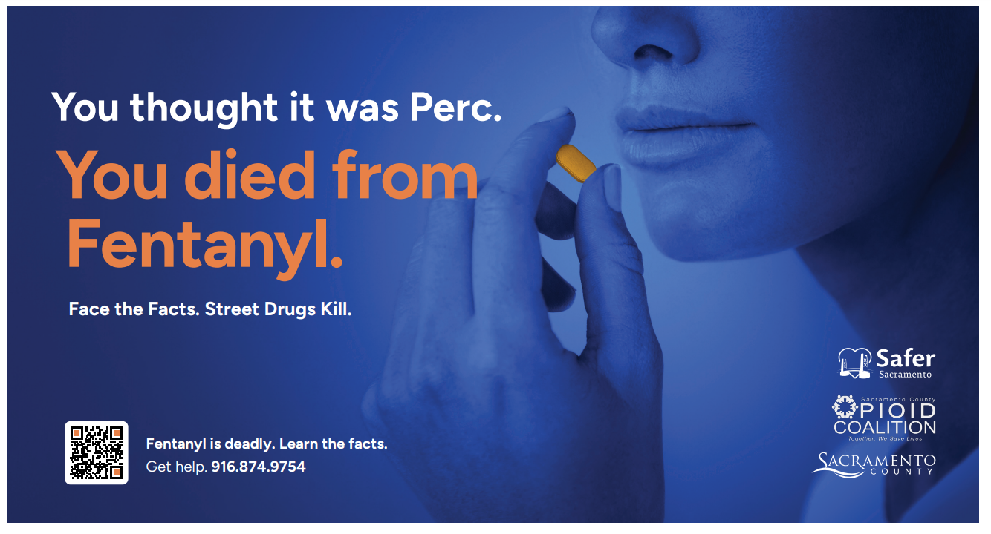

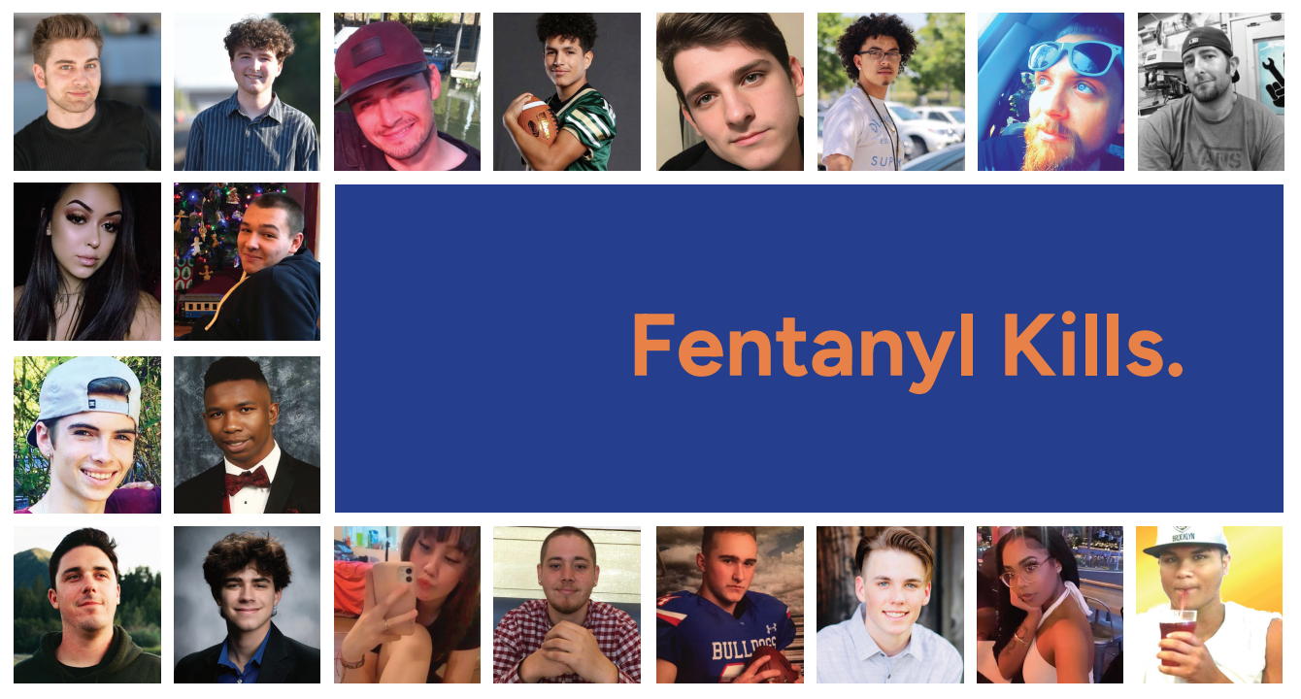

- Parent Resource - “New Drug Talk”, www.SongforCharlie.org

This site provides education, free tools, and expert advice to help CA families connect and stay safe.

- SUPT Collaboration with Correctional Health-Jail Inmate Tablet Project
- SUD and Mental Health education, resources and videos
- Fentanyl Education and Awareness
This Photo by Unknown Author is licensed under CC BY-NC
- 3200 inmates impacted

- NEW BOOKS

The Club, No Parent Should Have to Join
Grappling with Child Loss by Jennifer Burruel
Shattered
Compilation of personal stories – stories of lives broken by substance abuse and how we put the pieces back together
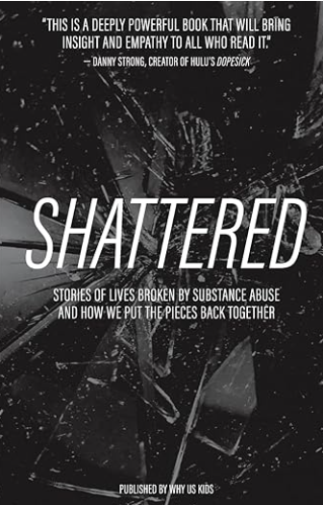

Fentanyl Nation by Ryan Hampton
A passionate call to abandon ineffective drug-war policies, reframe addiction as a public health crisis and end the Fentanyl crisis
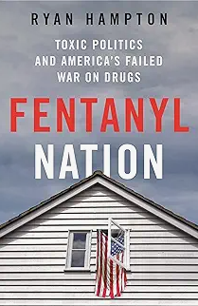

New Infant Fentanyl Syndrome Identified
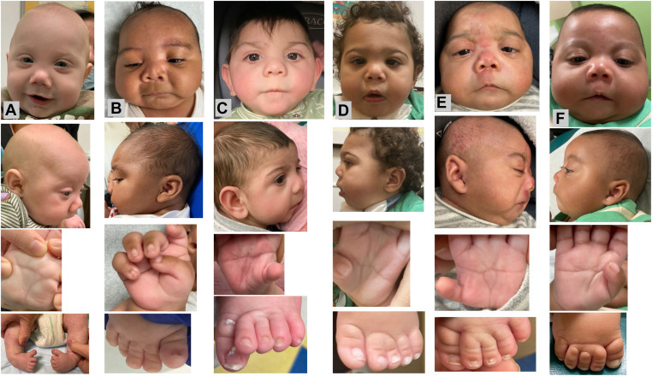

As America's fentanyl crisis continues to spiral out of control, doctors have identified 10 babies born with congenital disabilities whose mothers used street drugs, including fentanyl, during pregnancy.

A new study led by researchers at Nemours Children's Hospital in Wilmington, Delaware identified several key recognizable traits the ten babies have in common, including small heads, genital abnormalities, cleft palates and clubfoot, among others. They also observed webbing between toes, and short and broad thumbs.

"This novel syndrome is clinically recognizable. The authors state:"In light of the ongoing fentanyl use epidemic, public health impact of the novel syndrome associated with prenatal fentanyl exposure is likely to be significant," and they recommend asking pregnant women about fentanyl and other drug use during prenatal care visits.

