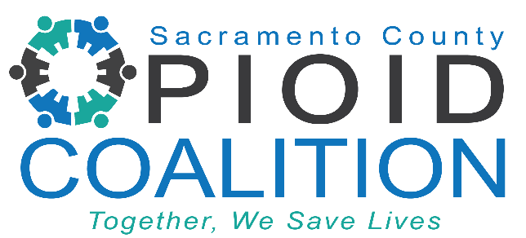
Sacramento County Opioid Coalition Meeting
Time: June 10, 2024 02:00 PM PT
Link Here
Meeting ID: 871 2647 4743
Passcode: 567540

Who we are: The Sacramento County Opioid Coalition is a collaboration of healthcare professionals, community-based organizations, law enforcement, County agencies, and concerned citizens determined to turn the tide of our local opioid epidemic.

Mission: We are committed to saving lives by preventing overdoses through expanding treatment access, promoting safe disposal, encouraging early intervention, treatment and recovery, enhancing opioid surveillance, and expanding public education and media outreach.

AGENDA

- Welcome by Facilitators 5 min
  - Lindsay Coate, Co-Chair, Sacramento County Opioid Coalition
- SCOC Community Updates 20 min
  - Lori Miller LCSW, Division Manager, Sacramento County Department of Health Services, Substance Use Prevention and Treatment
  - Amber Arif, Program Coordinator, Sacramento County Opioid Coalition
- New Opioid Surveillance Database 10 min
  - Felix Tran MPH, Epidemiologist at Sacramento County Public Health
- The Evolution of Polysubstance Use in America’s Fentanyl Crisis 30 min
  - Kelly Olson PhD, Director of Clinical Affairs at Millenium Health
- Lived Experience Speaker 20 min

