**SACRAMENTO COUNTY OPIOID COALITION**

**SUBSTANCE USE PREVENTION AND TREATMENT REPORT**

**10/21/24**

1. **Data-Sacramento County Coroner**

* 2023: 410 fentanyl involved deaths (not final count still open cases)
* 2024: 167
* 2022: 226; 2021: 215
* CDC – 7/10 pills on street and online laced with Fentanyl
* Fentanyl Dashboard on Coroner website

1. **NEW Opioid Dashboard,** [**www.sacopioidcoalition.org**](http://www.sacopioidcoalition.org)
2. **Safer Sacramento –** [**www.safersacramento.com**](http://www.safersacramento.com) **Updates:**



* NEW Blog – “The Ripple Effect”. 6th blog live of Documentary style 8 part series.
* Reaching Diverse Communities, Senior/Older Adult Pages Live
* Youth and Grief Pages Coming Soon
* Follow Safer Sacramento on Facebook, Instagram and TikTok

1. **Narcan Distribution and Ordering Process**

Contact Janelle Gonzales; [Gonzalesjan@saccounty.gov](mailto:Gonzalesjan@saccounty.gov) for information and Narcan

* **Sacramento County :**

[**www.safersacramento.com**](http://www.safersacramento.com)

[**DHS-SUPT@saccounty.gov**](mailto:DHS-SUPT@saccounty.gov)

* **DHCS Naloxone Distribution Project :** <https://californiaopioidresponse.org/matproject/naloxone-distribution-project/>

**January 15, 2025 - Title of Session: Marijuana and Pregnancy: A Public Health Perspective**

Time: 1:00 pm - 2:00 pm

Register in advance for this training: <https://www.zoomgov.com/meeting/register/vJItd--rqD8pG0SBIZLTl8W-3fTAcalv9kM>

1. **Opioid Settlement Funding – New and Expanded Sacramento County Contracted Services to Address the Opioid Crisis**

* Harm Reduction Services/SANE - MAT, Narcan distribution
* NTI Upstream/Safer Sacramento Prevention Project and Website
* Voice of the Youth – opioid education, prevention to African American youth ages 12-24
* Omni Youth Services, prevention education to hard to serve culturally diverse communities
* Center for Collaborative Planning/expand *See Her Bloom* campaign, opioid education and resources to African American women
* Sac Metro Fire Mobile Integrated Health/MAT services and Narcan distribution

**Postcard of Those Lost in Sacramento for download: Remembrance Page – Safer Sacramento**

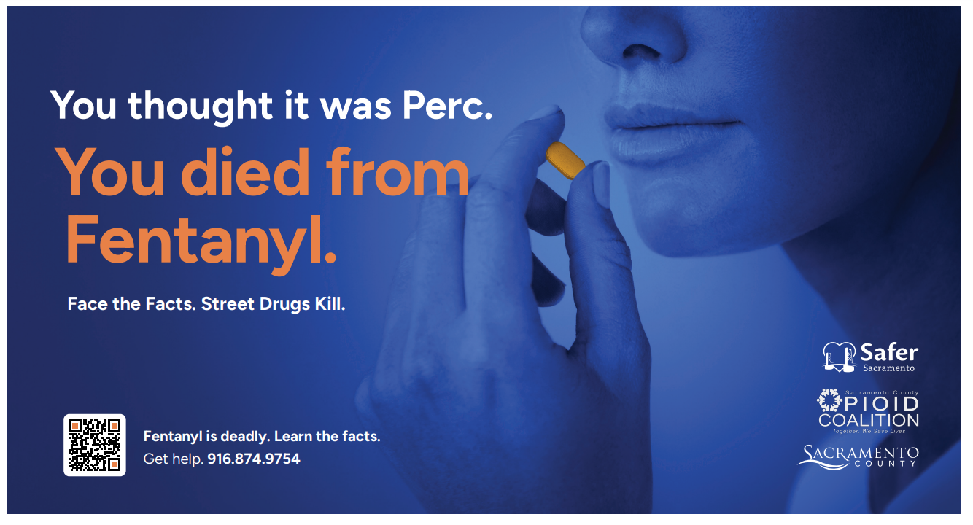

1. **Parent Resource - “New Drug Talk”,** [www.SongforCharlie.org](http://www.SongforCharlie.org)

**This site provides education, free tools, and expert advice to help CA families connect and stay safe.**



***Fentanyl Nation*** by Ryan Hampton

A passionate call to abandon ineffective drug-war policies, reframe addiction as a public health crisis and end the Fentanyl crisis

