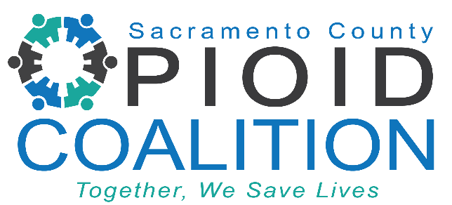

**Sacramento County Opioid Coalition Meeting**

Time: October 21, 2024 02:00 PM PT

[Link Here](https://us02web.zoom.us/meeting/register/tZEpcOmtrjgrE9R4SqRCpDRvdEgcSZJPc84T)

Meeting ID: 854 7050 3190

Passcode: 733329

**Mission:** The Sacramento County Opioid Coalition’s mission is to save lives by reducing opioid misuse, overdose, and stigma through community collaboration.

AGENDA

1. Welcome by Facilitators 5 min
   * Lindsay Coate, *Co-Chair, Sacramento County Opioid Coalition*
2. SCOC Community Updates 20 min
   * Lori Miller *LCSW, Division Manager, Sacramento County Department of Health Services, Substance Use Prevention and Treatment*
   * Amber Arif, *Program Coordinator, Sacramento County Opioid Coalition*
3. Lived Experience Guest Speaker 20 min
   * Jamie Lindsay, *Commercial Sexual Exploitation of Children (CSEC) with Stanford Sierra Youth and Families*
4. Sacramento County Behavioral Health Services – New Call Center for Mental Health and Substance Use Treatment 40 min
   * Lori Miller *LCSW, Division Manager, Sacramento County Department of Health Services, Substance Use Prevention and Treatment*